What causes melanoma and other types of cancer?

To begin, watch the video, “Teen Survives Deadly Melanoma” (https://www.youtube.com/watch?v=Zj4Bbu0xwRY).

1. What questions do you have about melanoma and the events described in the video?

You will learn the answers to many of your questions as you complete this activity.

What is melanoma?

Melanoma is a type of skin cancer. A melanoma begins when a type of skin cell called a melanocyte divides excessively and the cells spread beyond their normal location. (See the first figure.)  A melanocyte is a type of skin cell that makes melanin and distributes it to other skin cells. (The second figure shows the normal shape and location of a melanocyte.)  Melanin is a molecule that absorbs UV rays, which prevents UV rays from damaging DNA.  2. Inside most skin cells, most of the melanin is located between the cell’s nucleus and the surface of the skin. How does that location allow melanin to protect the cell’s DNA? | 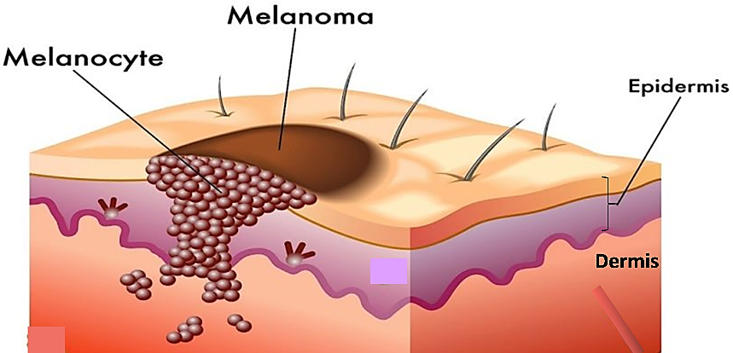
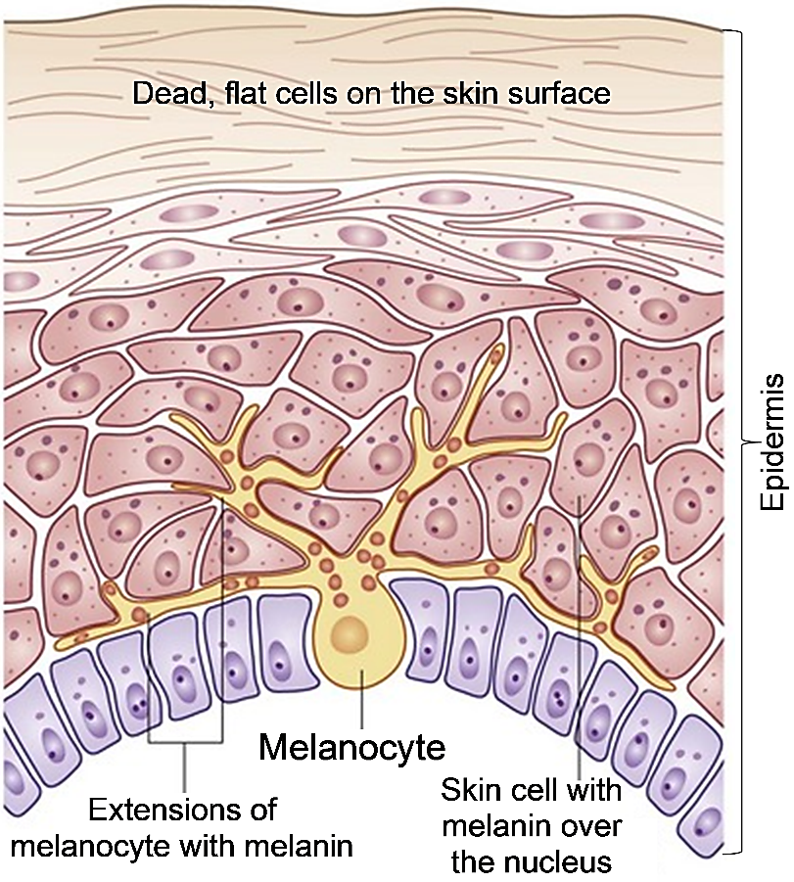
Cross-section through skin, showing a normal melanocyte that makes melanin and distributes it through long narrow extensions to many other skin cells

How does a melanoma develop?

UV light can damage the DNA of skin cells. If the damage is not repaired correctly, this results in a mutation. A mutation is a permanent change in the DNA. This figure shows how multiple mutations in the DNA of melanocytes can result in a melanoma.

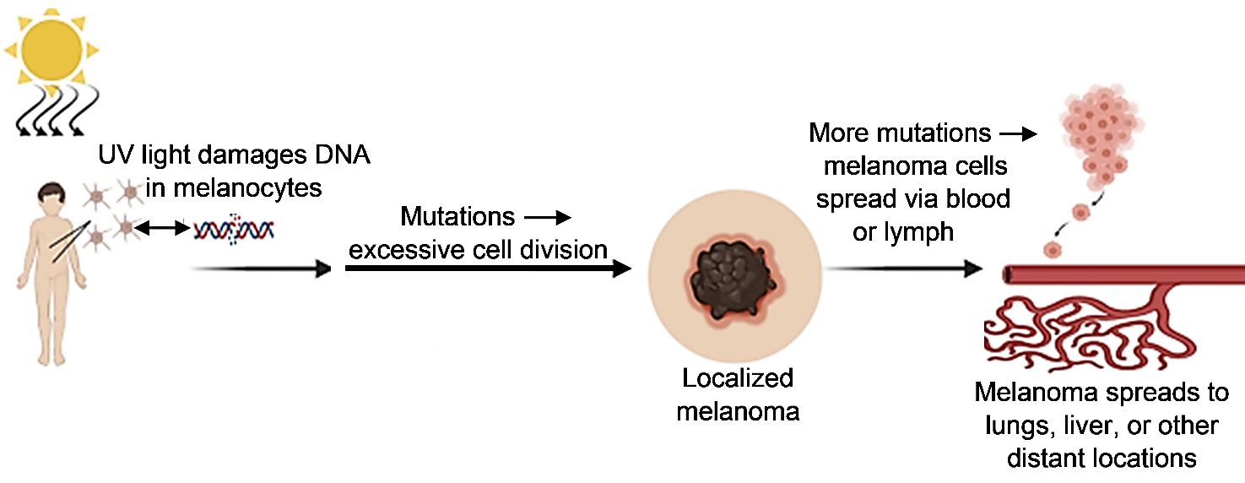

3. The next three paragraphs describe how a melanoma can develop. Put the letter for each paragraph next to the corresponding part of the figure.

A. Mutations in the DNA of melanocytes can disrupt the normal regulation of cell division, which can result in excessive, out-of-control cell division. This produces a localized melanoma. Surgical removal of a localized melanoma can cure the cancer.

B. If a localized melanoma is not surgically removed, then the DNA of the melanoma cells may accumulate more mutations that allow these cells to spread via the circulatory and lymph systems. In the lymph nodes, immune cells can attack and kill the melanoma cells.

C. If the immune cells and surgery do not eliminate all of the melanoma cells, the surviving melanoma cells can establish metastatic melanoma in the lungs, liver or other organs. Metastatic melanoma can kill a person by interfering with the function of the organ where it is located and by using so much nutrition that healthy cells in the rest of the body do not get adequate nutrition.

4a. The first doctor of the teen in the video removed the melanoma on her face. However, he warned her that the melanoma could kill her in five years. After the melanoma on her face was removed, where could melanoma cells be in her body?

4b. How could the melanoma eventually result in her death?

To prevent the melanoma from possibly killing the teen, her second doctor removed lymph nodes (in case they contained melanoma cells). He also prescribed medicines to help her immune cells recognize and destroy melanoma cells more effectively.

Why do melanoma cells divide too much?

Compare cell division in cancer cells vs. normal cells by watching “Cancer: Unregulated Cell Division” (https://www.youtube.com/watch?v=IeUANxFVXKc).

To understand why melanoma cells divide too much, you first need to understand that normal cell division is regulated by checkpoints. At the first checkpoint, a normal cell begins cell division only if growth factor is bound to a receptor protein and the cell’s DNA is not damaged.

Growth factor is a signal that more melanocytes are needed, so cell division should proceed. If there is no growth factor, then a normal melanocyte will not divide and instead will differentiate to begin producing melanin and distributing melanin to other skin cells.

This figure shows a few of the molecules that contribute to the function of this first checkpoint.
When growth factor binds to a receptor protein in the cell membrane, this activates a series of relay proteins. The activation of the final relay protein allows cell division to begin.

5. Suppose that UV rays have damaged the DNA in a melanocyte and caused a mutation in the gene for the final relay protein. Suppose that this mutated gene gives the instructions for making an abnormal relay protein which is permanently active, even when no growth factor is bound to the receptor protein. How would this mutation contribute to the development of a melanoma?

In addition to checkpoint proteins that can move the cell cycle forward, there are checkpoint proteins that can pause the cell cycle when needed. For example, if a cell’s DNA is damaged, the p53 checkpoint protein pauses the cell cycle and stimulates the production of DNA repair enzymes. If the cell cannot repair the DNA damage, the p53 checkpoint protein stimulates the cell to kill itself (sometimes called “cell suicide”).

6a. How does this “cell suicide” response help to preserve your health?

6b. Suppose that both copies of the p53 gene are mutated, so a cell has no functional p53 protein. Explain how this would contribute to the development of a melanoma.

In summary, mutated genes that result in defective checkpoint proteins make major contributions to the development of a melanoma.

Environment and inherited genes influence your risk of melanoma.

7. A person who has had sunburns as a child or teen is more likely than a person who has never had a sunburn to develop melanoma. Explain why. (Hint: Review the top of page 2.)

Recommendations to reduce your risk of melanoma and other skin cancers are as follows.
- Apply enough sunscreen of the right type and/or wear clothing to protect your skin from the UV rays in sunshine.
- Stay indoors or in the shade during the middle of the day, when sunlight is most intense.
- Avoid the UV light in tanning booths.

8. How will these recommended behaviors reduce your risk of melanoma?

The mutations induced by UV light are called somatic mutations because they occur in the body’s cells after birth. Inherited mutations (called alleles) can also contribute to the development of melanoma.

9a. A human gene gives the instructions for making a protein that helps to repair the type of DNA damage caused by UV light. Rarely, a person inherits two mutated copies of this gene, and both copies give instructions for making inactive versions of this repair enzyme. This person’s risk of melanoma would be much ____________ than normal.
(higher / lower)
9b. Explain your reasoning.

10. People who inherit alleles for darker skin have more melanin in their skin cells than people who inherit alleles for lighter skin. Explain how alleles for darker skin reduce the risk of developing melanoma.

11. Add to the first two boxes in this flowchart to describe factors that influence a person’s risk of melanoma.
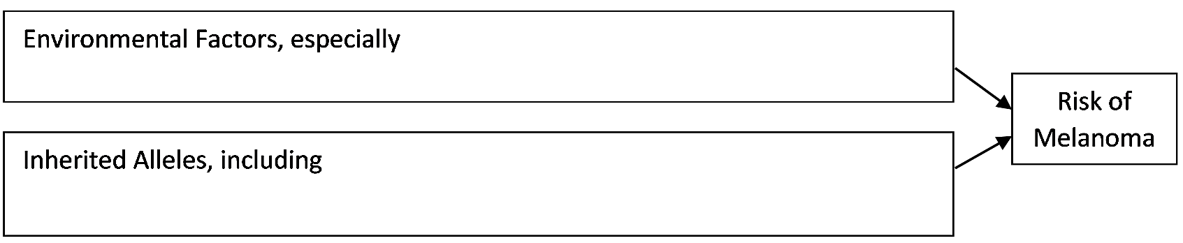
Different Types of Cancer
Melanoma is just one of the many different types of cancer. Cancer is any disease caused by excessive cell division and the ability of cancer cells to invade other tissues. All cancers develop through similar biological processes.

12. Review what you have learned about the development of metastatic melanoma. List four things that you think probably apply to the development of other types of cancer.

Despite the similarity of the underlying biological processes, there are important differences between the types of cancer that develop in different parts of the body. For example, cigarette smoking dramatically increases the risk of lung cancer, but not melanoma. Cigarette smoke contains chemicals that can damage DNA and cause mutations.

13. Behaviors as different as smoking cigarettes and unprotected exposure to the UV rays in sunlight contribute to increased risk of cancer. What do these risky behaviors have in common?

14. Explain why (1) cigarette smoking increases the risk of lung cancer, but not melanoma, whereas (2) unprotected exposure to intense sunshine increases the risk of melanoma, but not lung cancer.

Research Challenge
15a. For your research topic, choose a question related to this activity that you would like to know more about. Write your question here.

15b. Use one or more of the following sources to answer your question.
- Melanoma Skin Cancer (https://www.cancer.org/cancer/melanoma-skin-cancer.html)
- Understanding Melanoma (https://www.aimatmelanoma.org/melanoma-101/understanding-melanoma/)
- Understanding Melanoma in Kids and Adults (https://kids.frontiersin.org/articles/10.3389/frym.2021.570445#:~:text=Melanoma%20is%20abnormal%20growth%20of,the%20diagnosis%20challenging%20for%20doctors.)
- Skin Cancer (Including Melanoma) (https://www.cancer.gov/types/skin)
- What is cancer? (https://www.cancer.gov/about-cancer/understanding/what-is-cancer and/or https://www.cancer.org/cancer/understanding-cancer/what-is-cancer.html and/or https://www.cancerresearchuk.org/about-cancer/what-is-cancer)
- Cancer Biology (has a 12-minute video; https://www.cancerquest.org/cancer-biology)
- Cell Cycle (and cancer) [updated] (https://www.youtube.com/watch?v=QVCjdNxJreE)
- Cancer and the Cell Cycle (https://www.khanacademy.org/science/ap-biology/cell-communication-and-cell-cycle/regulation-of-cell-cycle/a/cancer)
- DNA proofreading and repair (https://www.khanacademy.org/science/biology/dna-as-the-genetic-material/dna-replication/a/dna-proofreading-and-repair)
- Cancer Types (https://www.cancer.gov/types)

By Dr. Ingrid Waldron, Department of Biology, University of Pennsylvania, © 2024. This Student Handout and Teacher Notes with biology background and instructional suggestions are available at https://serendipstudio.org/exchange/bioactivities/melanoma .

